

Software development and production practice report

Personal blog system

1. Internship purpose
Fully understand the process of software project implementation, and understand the basic quality and technical ability requirements of software enterprises for programmers.
Focus on cultivating students' team spirit and sense of cooperation, and improve their oral and written communication skills.
Master the fast learning of new knowledge, new technologies and methods, and cultivate a good ability to analyze and solve problems.
Focus on improving students' programming ability, so that students can establish correct

2．Project and system design

2.1 system development environment
Operating system: Windows 10
Integrated development tool: Eclipse
Compilation Environment: JDK 1.8
Web Server: Tomcat 9.0

2.2 System design ideas
The system uses the architecture of B / S, design and development using JSP development tools, the front-end uses html, js and other technologies, based on MVC schema, the implementation of the database with MySQL, Web server for Tomcat.The research process adopts the traditional waterfall model, which effectively guides the whole development process with the stage review and document control of the project.The system is divided into three layers: Model layer (complete the definition of entity class), Web layer (mainly complete the page display and response to user requests), and Dao layer (mainly complete the interaction with database).

2.3 System common code design

2.3.1 Page component class
1) Functional description
We defined the PageBean class at the design time, completing the function of paging query and log list display.We write a method to get the total number of records of the current log in the userDao class of the Dao layer; then write the PageBean component in the MainServlet of the Web layer, when we click on the last page, next page or several page, we send the current page page to the background, so we need to get the page in the background.If the page is empty, Then, set it to 1; Write down another component of the PageBean, Let diaryList query the results not only have all the data, Finally, it is shown in the form of paging; Let's add a pageBean parameter to the diaryList method inside the Dao layer, Additional paging query; among, The construction method of PageBean has two parameters, One is the current page page, Is that the data that we get from the front desk, The other is the number of records per page, We can set the size of the pageSize in the properties file; Finally, write the front ing at the Wen level, In MianServlet, The logic inside this we put in the background implementation, Use StringBuffer for splicing; And to get the implementation of the paging function, Write a way to get a pageCode, The parameters are the total number of records of the log, Current page and the amount of data per page; Then the doPost() method in the MainServlet is called inside.
- Class and method description
- (1)PageBean
returned value | Method name | function | parameter declaration
int | getPage() | Returns the number of pages
int | getPageSize() | Returns the number of records per page
int | getStart() | Calculate the start page

2.3.2 Filter component classes
1) Functional description
doFilter(ServletRequest request, ServletResponse response, FilterChain chain)
The doFilter() method is similar to the service() method of the Servlet interface.When the client requests the target resource, the container invokes the doFilter() method of the filter associated with this target resource.Where the parameter, request, The response is the request and the corresponding object passed over by the previous Filter of the web container or Filter chain; The parameter chain is the object that represents the current Filter chain, After the specific operation is completed, The chain.doFilter of the FilterChain object can be called within the doFilter method of the current Filter object (request, response) The method can deliver the request to the next Filter or target Servlet program in the Filter chain, Response information can also be returned directly to the client, Or by using RequestDispatcher's forward() and include() methods, And the HttpServletResponse's sendRedirect() method to turn the request to other resources.The types of request and response parameters for this method are ServletRequest and ServletResponse, that is, the use of the filter does not depend on the specific protocol.

2.3.2 Background Module Test
On the front page of the front desk, you can click the login background button to log to the background management page. On the background management page, you can conduct blog management, blog category management, review and personal information management and system management.But first to get the user name and password, have the blogger permission to enter the background management page, first enter the user name: admin, and then enter the password: 123. There are two kinds of results, one is the correct password and successful login, the other is unsuccessful, login failure, if the failure, it will hit the red font on the page: user name or password error.

2.4 Functional module design

2.4.1 Log category add and modification module
function declaration ：

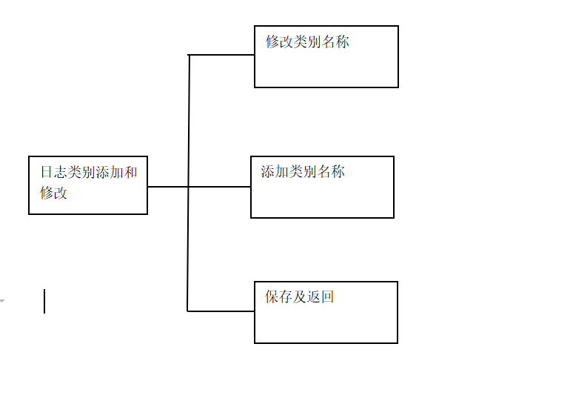

Class and method design：
Add the log category：
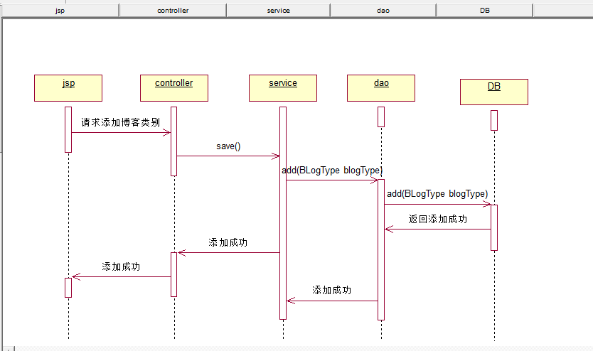

Delete the log category：
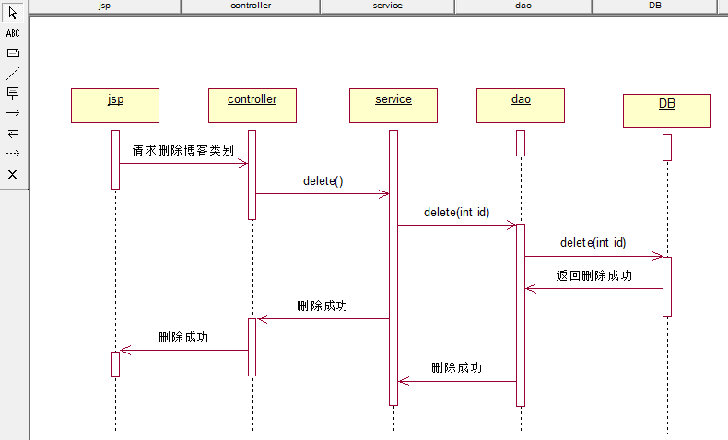
1.The dao layer, write to add with modify the method；
In this case, we are mainly in DiaryTypeDao to write ways to add log categories and modify log categories；
//Log category added
public int diaryTypeAdd(Connection con,DiaryType diaryType) throws Exception{
String sql="insert into t_diarytype values(null,?)";
PreparedStatement pstmt=con.prepareStatement(sql);
pstmt.setString(1,diaryType.getTypeName());
return pstmt.executeUpdate();
}

//Log category modification
public int diaryTypeUpdate(Connection con,DiaryType diaryType) throws Exception{
String sql="update t_diarytype set typeName=? where diaryTypeId=?";
PreparedStatement pstmt=con.prepareStatement(sql);
pstmt.setString(1,diaryType.getTypeName());
pstmt.setInt(2,diaryType.getDiaryTypeId());
return pstmt.executeUpdate();
}
2.The web layer, inside the DiaryTypeServlet, calls the previous method;
Here we call the previous addition and modification method in DiaryTypeServlet;
Note: Whether it is to add the log category or modify the log here, we will finally show the page of the log category information, namely the diaryTypeSave.jsp page;
The diaryTypeSave.jsp page:
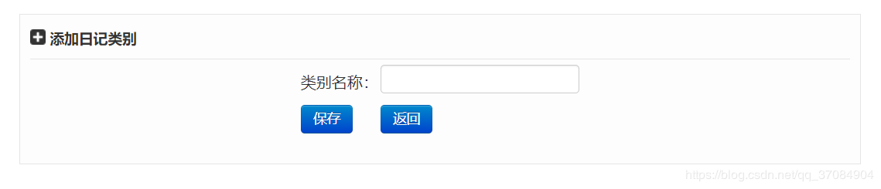

Let's build a new diaryTypeSave.jsp page first：
<%@ page contentType="text/html;charset=UTF-8" language="java" %>
<!-- 使用JSTL标签需要引入的头文件 -->
<%@ taglib uri="http://java.sun.com/jsp/jstl/core" prefix="c"%>
<!-- 使用fmt 对时间进行格式化的时候需要引入的头文件 -->
<%@ taglib prefix="fmt" uri="http://java.sun.com/jsp/jstl/fmt"%>
<html>
<head>
<title>Title</title>
<script type="text/javascript">
function checkForm(){
var typeName=document.getElementById("typeName").value;
if(typeName==null||typeName==""){
document.getElementById("error").innerHTML="类别名称不能为空！";
return false;
}
return true;
}
</script>
</head>
<body>
<div class="data_list">
<div class="data_list_title">
<c:choose>
<c:when test="${diaryType.diaryTypeId!=null }">
<img src="${pageContext.request.contextPath}/images/diary_type_edit_icon.png"/>
修改日记类别
</c:when>
<c:otherwise>
<img src="${pageContext.request.contextPath}/images/diaryType_add_icon.png"/>
添加日记类别
</c:otherwise>
</c:choose>
</div>
<form action="diaryType?action=save" method="post" onsubmit="return checkForm()">
<div class="diaryType_form" >
<table align="center">
<tr>
<td>类别名称：</td>
<td><input type="text" id="typeName" name="typeName" value="${diaryType.typeName }" style="margin-top:5px;height:30px;" /></td>
</tr>
<tr>
<%--日志类别主键，设置为隐藏域--%>
<input type="hidden" id="diaryTypeId" name="diaryTypeId" value="${diaryType.diaryTypeId }"/>
<td><input type="submit" class="btn btn-primary" value="保存"/></td>
<td><button class="btn btn-primary" type="button" onclick="javascript:history.back()">返回</button>&nbsp;&nbsp;<font id="error" color="red">${error }</font> </td>
</tr>
</table>
</div>
</form>
</div>
</body>
</html>
The way to judge whether to add log category or modify log category is that we judge whether diaryTypeId is empty;
Inside of the DiaryTypeServlet：
//Method to preprocess log categories
private void diaryTypePreSave(HttpServletRequest request, HttpServletResponse response) throws ServletException, IOException{
String diaryTypeId=request.getParameter("diaryTypeId");
Connection con=null;
try {
if(StringUtil.isNotEmpty(diaryTypeId)){
con=dbUtil.getCon();
DiaryType diaryType=diaryTypeDao.diaryTypeShow(con,diaryTypeId);
request.setAttribute("diaryType",diaryType);
}
//Connect the resulting mainPage and diaryTypeSave
request.setAttribute("mainPage", "diaryType/diaryTypeSvae.jsp");
//inter forwarding
request.getRequestDispatcher("mainTemp.jsp").forward(request, response);
} catch (Exception e) {
e.printStackTrace();
} finally{
try {
dbUtil.closeCon(con);
} catch (Exception e) {
e.printStackTrace();
}
}
}

//Method to add a log category
private void diaryTypeSave(HttpServletRequest request, HttpServletResponse response) throws ServletException, IOException{
String diaryTypeId=request.getParameter("diaryTypeId");
String typeName=request.getParameter("typeName");
DiaryType diaryType=new DiaryType(typeName);
if(StringUtil.isNotEmpty(diaryTypeId)){
diaryType.setDiaryTypeId(Integer.parseInt(diaryTypeId));
}
Connection con=null;
try {
con=dbUtil.getCon();
int saveNum;
if(StringUtil.isNotEmpty(diaryTypeId)){
saveNum=diaryTypeDao.diaryTypeUpdate(con, diaryType);
} else{
saveNum=diaryTypeDao.diaryTypeAdd(con, diaryType);
}
if(saveNum>0){
//添加成功，跳转到日志列表页面
request.getRequestDispatcher("diaryType?action=list").forward(request, response);
}else{
request.setAttribute("diaryType", diaryType);
request.setAttribute("error", "保存失败！");
//将得到的mainPage和diarySave连接起来
request.setAttribute("mainPage", "diaryType/diaryTypeSvae.jsp");
//内部转发
request.getRequestDispatcher("mainTemp.jsp").forward(request, response);
}
} catch (Exception e) {
// TODO Auto-generated catch block
e.printStackTrace();
} finally{
try {
dbUtil.closeCon(con);
} catch (Exception e) {
// TODO Auto-generated catch block
e.printStackTrace();
}
}
}
Of course, here we also add a method diaryTypeShow to display the log category information in the previous dao layer;
/ / Display the log categories according to the log Id
public DiaryType diaryTypeShow(Connection con,String diaryTypeId) throws Exception{
DiaryType diaryType=new DiaryType();
String sql="select * from t_diaryType where diaryTypeId=?";
PreparedStatement pstmt=con.prepareStatement(sql);
pstmt.setString(1,diaryTypeId);
ResultSet rs=pstmt.executeQuery();
if(rs.next()){
diaryType.setDiaryTypeId(rs.getInt("diaryTypeId"));
diaryType.setTypeName(rs.getString("typeName"));
}
return diaryType;
}

3.We add a link to the foredesk page；
On the diaryTypeList.jsp page：

Add a log category link：<button class="btn btn-primary btn-success" type="button" onclick="javascript:window.location='diaryType?action=preSave'">添加日志类别</button>
Modify the log category link： <button class="btn btn-primary btn-info" type="button" onclick="javascript:window.location='diaryType?action=preSave&diaryTypeId=${diaryType.diaryTypeId }'">modify</button>&nbsp;
Both links are passed to the background by the action=preSave request；
The link to modify the log category will pass one more diaryTypeId, judging to the background to see whether it is modified or added;
Finally, we judge the diaryTypeId in the method of adding a log in the diaryTypeServlet,
If empty is an added operation, not empty is a modification operation;
（2）diaryTypeAdd class
The function of this class：Log category added
returned value | Method name | function | parameter declaration
pstmt.executeUpdate() | diaryTypeAdd | Log category added | Connection con（连接）,  DiaryType diaryType（自定义日志类别）
（3） data sheet

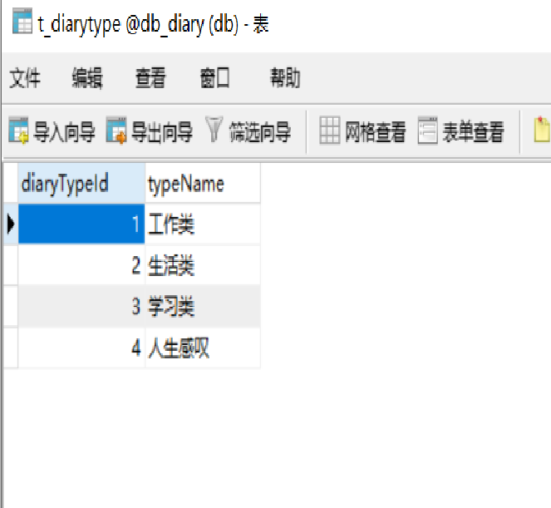

2.4.2 Log-type E-R diagram
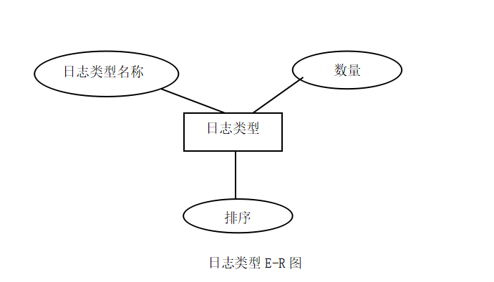

The relationship pattern of log type class is as follows (main key with slide line)：
Log Type Entity (number, Blog type name, quantity, sort).

2.4.3 Background main interface construction
1.The Bootstrap's navigation bar
First, write down the navigation bar:

<!-- 反色的导航条，且固定在顶部 -->
<div class="navbar navbar-inverse navbar-fixed-top">
<div class="navbar-inner">
<!-- 设置容器，内容都写在这里面 -->
<div class="container">
<!-- brand是标题 -->
<a class="brand" href="#">屌丝的日记本</a>
<!-- nav-collapse是设置响应式的导航条 -->
<div class="nav-collapse collapse">
<!-- nav是设置导航标签 -->
<ul class="nav">
<li class="active"><a href="#"><i class="icon-home"></i>&nbsp;主页</a></li>
<li class="active"><a href="#"><i class="icon-pencil"></i>&nbsp;写日记</a></li>
<li class="active"><a href="#"><i class="icon-book"></i>&nbsp;日记分类管理</a></li>
<li class="active"><a href="#"><i class="icon-user"></i>&nbsp;个人中心</a></li>
</ul>
</div>
<!-- 搜索表单 -->
<!-- 导航栏内的表单，用navbar-form进行样式化，pull-right是设置居右显示 -->
<form name="myForm" class="navbar-form pull-right" method="post" action="">
<input class="span2" id="s_title" name="s_title" type="text" style="margin-top:5px;height:30px;" placeholder="往事如烟...">
<button type="submit" class="btn" onkeydown="if(event.keyCode==13) myForm.submit()"><i class="icon-search"></i>&nbsp;搜索日志</button>
</form>
</div>
</div>
</div>

effect:
pay attention to:
Here you need to import two jar packages, respectively, jstl.jar and standard.jar;
2. Flow layout of the page (support for responsive):
<!-- The layout is a flow layout container:row-fluid，And each row is full of 12 grids -->
<div class="container">
<div class="row-fluid">

<div class="span9">
<div class="data_list">
<div class="data_list_title">
<img src="${pageContext.request.contextPath}/images/list_icon.png"/>
日记列表
</div>
</div>
</div>

<div class="span3">
<div class="data_list">
<div class="data_list_title">
<img src="${pageContext.request.contextPath}/images/user_icon.png"/>
个人中心
</div>
</div>

<div class="data_list">
<div class="data_list_title">
<img src="${pageContext.request.contextPath}/images/byType_icon.png"/>
按日志类别
</div>
</div>

<div class="data_list">
<div class="data_list_title">
<img src="${pageContext.request.contextPath}/images/byDate_icon.png"/>
按日志日期
</div>
</div>
</div>

</div>
</div>

效果：

3. main.jsp完整代码：

main.jsp：

<%@ page language="java" contentType="text/html; charset=utf-8" pageEncoding="utf-8"%>
<%@ taglib uri="http://java.sun.com/jsp/jstl/core" prefix="c"%>
<html lang="zh">
<head>
<meta http-equiv="Content-Type" content="text/html; charset=utf-8">
<meta name="viewport" content="width=device-width, initial-scale=1.0">
<title>个人日记本主页</title>
<link href="${pageContext.request.contextPath}/style/diary.css" rel="stylesheet">
<link href="${pageContext.request.contextPath}/bootstrap/css/bootstrap.css" rel="stylesheet">
<link href="${pageContext.request.contextPath}/bootstrap/css/bootstrap-responsive.css" rel="stylesheet">
<script src="${pageContext.request.contextPath}/bootstrap/js/jQuery.js"></script>
<script src="${pageContext.request.contextPath}/bootstrap/js/bootstrap.js"></script>
<!-- 将布局与导航栏分离开来，避免重叠 -->
<style type="text/css">
body {
padding-top: 60px;
padding-bottom: 40px;
}
</style>
</head>
<body>
<!-- 反色的导航条，且固定在顶部 -->
<div class="navbar navbar-inverse navbar-fixed-top">
<div class="navbar-inner">
<!-- 设置容器，内容都写在这里面 -->
<div class="container">
<!-- brand是标题 -->
<a class="brand" href="#">屌丝的日记本</a>
<!-- nav-collapse是设置响应式的导航条 -->
<div class="nav-collapse collapse">
<!-- nav是设置导航标签 -->
<ul class="nav">
<li class="active"><a href="#"><i class="icon-home"></i>&nbsp;主页</a></li>
<li class="active"><a href="#"><i class="icon-pencil"></i>&nbsp;写日记</a></li>
<li class="active"><a href="#"><i class="icon-book"></i>&nbsp;日记分类管理</a></li>
<li class="active"><a href="#"><i class="icon-user"></i>&nbsp;个人中心</a></li>
</ul>
</div>
<!-- 搜索表单 -->
<!-- 导航栏内的表单，用navbar-form进行样式化，pull-right是设置居右显示 -->
<form name="myForm" class="navbar-form pull-right" method="post" action="">
<input class="span2" id="s_title" name="s_title" type="text" style="margin-top:5px;height:30px;" placeholder="往事如烟...">
<button type="submit" class="btn" onkeydown="if(event.keyCode==13) myForm.submit()"><i class="icon-search"></i>&nbsp;搜索日志</button>
</form>
</div>
</div>
</div>

<!-- 布局采用流式布局容器即row-fluid，且每一行都是12个栅格 -->
<div class="container">
<div class="row-fluid">

<div class="span9">
<div class="data_list">
<div class="data_list_title">
<img src="${pageContext.request.contextPath}/images/list_icon.png"/>
日记列表
</div>
</div>
</div>

<div class="span3">
<div class="data_list">
<div class="data_list_title">
<img src="${pageContext.request.contextPath}/images/user_icon.png"/>
个人中心
</div>
</div>

<div class="data_list">
<div class="data_list_title">
<img src="${pageContext.request.contextPath}/images/byType_icon.png"/>
按日志类别
</div>
</div>

<div class="data_list">
<div class="data_list_title">
<img src="${pageContext.request.contextPath}/images/byDate_icon.png"/>
按日志日期
</div>
</div>
</div>

</div>
</div>
</body>
</html>

Style file:diary.css：

.data_list{
border: 1px solid #E5E5E5;
padding: 10px;
background-color: #FDFDFD;
margin-top: 15px;
}

.data_list .data_list_title{
font-size: 15px;
font-weight: bold;
border-bottom: 1px solid #E5E5E5;
padding-bottom: 10px;
padding-top: 5px;
}

.data_list .data_list_title img{
vertical-align: top;
}

2.5 Database design

2.5.1 function declaration
dairytypeThe table stores all the log categories, including four fields, namely, work, life, learning, and life exclamation.The log category management system can add, modify, and delete log type names and sort numbers.The press by log category area appears to the home page.Visitors can look up the relevant log content of interest from here.

2.5.2Data sheet design

Table name：dairytype Table function description
字段名 | 类型 | 可为空 | 默认 | 注释
工作类 | 文本
生活类 | 文本
学习类 | 文本
人生感叹 | 文本

2.5.3View design

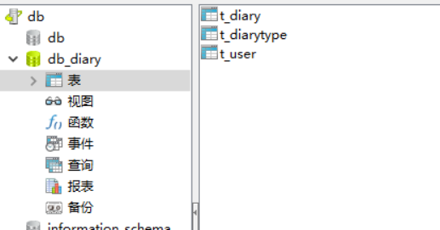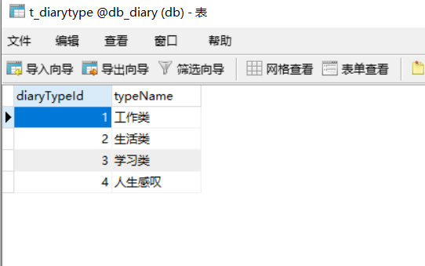

2.5.4data dictionary
data file ：dairytype table
File composition：Log category, log category number, type.

Data item: Log category
Data type: Text
Data length: 20
Data item: Log category number
Data type: the whole type
Data length: 2
Data item: Type
Data type: Text
Data length: 8

3.Similar website research report writing, website material collection, website layout planning
Personal blogging is a way for people to show their personality on the web.As the Internet plays an increasingly important role in people's lives, everyone likes to get all kinds of information through the Internet.On the Internet, you can also speak freely, and personal blogs are one of them.On a personal blog, you can post your heart journey, post your work experience, publish your technology blog, and more.
First introduce what is blog, blog is a transliteration word, its English name is Blogger, it is also called web log.It is usually defined as a website that is usually personally managed and irregularly published.
A Blog is a web page that is composed of a wide variety of posts.These posts can be your feelings about watching a movie one day, you can also be about reading a book, but also you can be your experience in your own technical field.It's a web page, but you can share your feelings with words or pictures, and the content it provides can be used to communicate.The main use is personal free expression and knowledge filtering and accumulation.
Examples of similar websites:
一、 feasibility analysis
The background technology used in this personal blog system is the Spring4 + Springmvc + Mybatis3 architecture, the mysql database, the maven3 for project management, and the Shiro as the project management framework.Front ground web page uses mainstream Bootstrap3 UI framework; database connection pool uses Alibaba Druid; online editor uses Baidu UEditor, supports single picture and multi-figure upload, supports long screenshots, supports code highlight and other features.These technologies are tested by the market, have been very mature, in the safety, availability, reliability and other aspects are worthy of affirmation
system design
According to the requirements analysis, the system design should include login module, Blog management module, blog category management module, comment management module, personal information management module, and system module.
Third, the system function realization
1) Landing interface
Add login button, after the blogger input account password and click login, the terminal first performs login () method, according to the user in the foreground interface input user name, password to find any matching data, if any, if not empty, the verification code is correct, the front desk prompts the error message is correct, and the interface jumps to the home page.

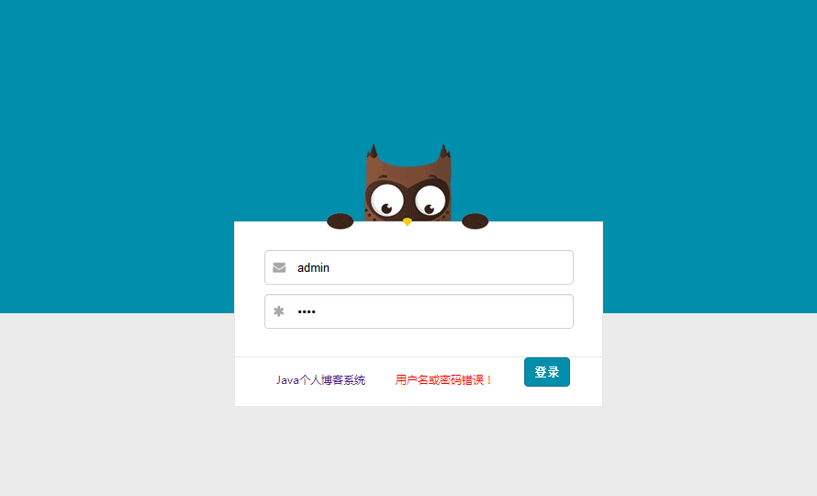

graph 1 Background Login Interface

2) Main interface of the administrator
Administrator interface, is to show some operations of the administrator on the main interface, different page jump, business transformation, through JDBC background data operation.

internship summary
After two weeks of intense study and work, my primary school curriculum design was finally completed timely and smoothly.
After this primary school curriculum design, I learned about the knowledge of JSP and MySQL database, so that I understand the importance of scripting language to JSP, and apply the JDBC driver of JSP to call the database.In this design process, I cultivated my self-study ability. When I encountered technical difficulties, I could treat it seriously and never give up. Whether I checked all kinds of books or found all kinds of materials in the library, I tried every means to solve the problem.I have summed up a lot of JSP programming experience, which will be of great help in the future study and life.
I designed the personal blog system, although the interface is a little rough, but the technical content is still high, for example, can achieve all kinds of information management and query browsing, of course, due to the short time, and their beginner, so the system still has deficiencies, which need to be improved in the future learning process.

